Spin1 build and installation Manual

Ok, you have the bare PCB, this is what you need to do:

1. Get the BOM from site, its in csv format, so you can select what modules you want populated.
A few things to note:
- EGT circuit won't work.
- The usb connector is plain wrong. In the BOM you can choose to buy a cable to use this wrong (female-A) connector, or buy another usb connector and hack things to install it.
- You don't want the shutdown circuit, so its FETs aren't in the BOM. Don't worry about that.
Once you are decided about the BOM, go to to digikey and place the order.

2. You have the PCB + components, so get kicad and the files, or the pdf files from puma.freeems.org. PDFs aren't searchable so you may want to choose to install kicad until we workout that.

3. Cut the wrong traces:

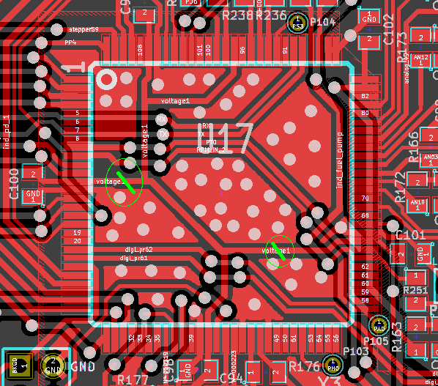Illustration 1: There are wrong MCU VDD traces

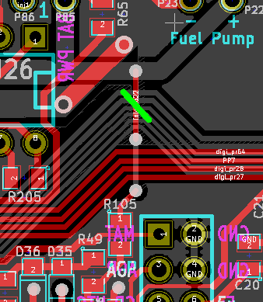Illustration 2: Change 12v reference source

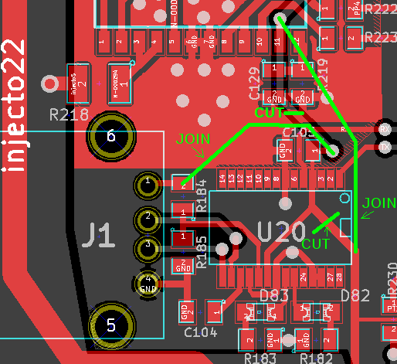Illustration 3: This supplies the FT232 from the PC instad of the internal reg

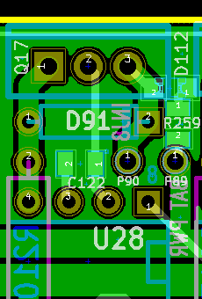Illustration 4: In case you use the peak&hold setup

3. Start the assembly!

Just solder the components. If you ordered a board, you should know how to do it. An oven is a fast way to get it done.

Don't put too much paste for the small regulator, or it will get misaligned.

4. Program the MCU using a BDM pod.

Install Codewarrior, open the programmer, go to File-> Load application, and select the .s12 (FreeEMS serial monitor).

It should get connected, program it, verify, and never complain.

5. Load FreeEMS firmware, using seank's loader.

6. Install MTX and connect to the board to the PC to check that freeems is running.

